ROYAL OAK INTERNATIONAL SCHOOL
SR. SEC. C.B.S.E. AFFILIATED (2019-20)
WHOLE YEAR SYLLABUS OF CLASS V

SUBJECT-ENGLISH

MONTH | NO. OF WORKING DAYS | CONTENT | ACTIVITY | VOCABULARY | WORKSHEET
April | 18 | MCB-L1- The right track  Poem: TWO LITTLE KITTENS  Dictation: L -1  Literature- The Boy and the Apple tree-I  Grammar- Nouns Punctuation, Simple present tense  Writing – Paragraph writing | Introduction and explanation of chapter, Q/Ans., back exercise  Related to Poem : RTC, central idea,  Story-Central Idea of the story Grammar-Clear concept of noun and its kinds.  Writing- Title of the paragraph , how to start and how to conclude | Read the story and write the central idea | Grammar- Noun and unseen passage
May | 8 | MCB-L- 2 – Mowgli friends,his family  Poem- My song  Dictation words  Literature- The Boy and the Apple tree-II  Grammar- Antonyms, Synonyms, Sentence  Writing- Diary Entry | Proper explanation of lesson, Q/Ans., back exercise  Value based question related to story  Literature- Back Exercise | Write few sentences about Mowgli | Grammar – Antonyms, verbs and Forms of Verb
July | 24 | MCB-L- 3- How things work  Poem – Secret of the machines  Literature-Rip Van Winkle -I  Grammar- Simple Present, Present Continuous, Pronoun  Writing-Advertisement, Informal letter | Q/Ans., fill ups, back exercises,  Poem-RTC with Central Idea.  Story- Story reading  Literature- Back exercises  Grammar- Concept of Simple Present and Present Continuous tense |  | Grammar – Simple Present tense, Present Continuous Tense  Writing –Advertisement, Informal Letter
Written Evaluation Syllabus: PAI(July) M.M.:- ( 40)
MCB- Unit 1- The right track
Poem- TWO LITTLE KITTENS
Unit 2- Mowgli friends,his family
Poem- My song
Literature- Ch-1-The Boy and the Apple tree-I
Ch-2-The Boy and the Apple tree-II
Grammar- Nouns, Punctuation, Simple present tense, Antonyms, Synonyms, Sentence
Writing- Paragraph writing, Diary Entry
Aug. | 25 | MCB-L-4: Travels of Marcopolo  Poem – From a railway carriage  Literature- Rip Van Winkle -II  Grammar- Present Perfect tense  Writing - Message Writing and Dialogue Completion | Answering question back exercises  Story- Story Reading  Literature- Back Exercises  Grammar- Proper explanation of Present Perfect Tense | Make a spellathon | Grammar –  Present Perfect tense
Sept. | 4 | MCB-L- 5- Hellen Keller  Literature- The shoemaker and the Elves  Grammar- Conjunctions | Answering question and back exercises  Literature- Back Exercises  Grammar- Concept- How to join two sentences | Write four sentences about Hellen Keller | Conjunctions
Written Evaluation Syllabus: Half-Yearly Exam(September) MM:-(60)
MCB- L- 3- How things work
Poem – Secret of the machines
Unit 4- Travels of Marcopolo
Poem – From a railway carriage
Unit 5- Hellen Keller
Literature- Ch-4 Rip Van Winkle –I
Ch-5-Rip Van Winkle –II
Ch-7The shoemaker and the Elves
Grammar- Simple Present, Present Continuous, Pronoun, Present Perfect tense, Conjunctions
Writing- Advertisement, Informal letter, Message Writing and Dialogue Completion + Grammar and
writing part of P.A.-I

Oct. | 17 | MCB-L – 7- It’s not fair  Poem – Weed to Bloom  Literature- Gulliver in the Land of the Little people -I  Grammar- Simple Past tense and Adverb  Writing – Formal letter | Back ex. and Que/Ans  Poem- RTC and meaning of phrases.  Story-Story reading  Writing- How to start a letter/context and how to end. | What lesson did you learn from the play It’s not fair | Simple Past tense and Adverb
Nov. | 9 | MCB-L-8- Robin Crusoe  Poem – Land of the story books  Literature- Gulliver in the Land of the Little people -II  Grammar- Adjectives, Past Continuous Tense and Homophones  Writing – Bio sketch of Abdul Kalam Azad and Vivekananda | Explanation and introduction of chapter  Poem-RTC and central idea of poem  Literature- Back exercises  Writing- Trying to inspire the students by discussing the qualities of great personalities | Paste the picture of a great hero and write four main qualities he poses | Grammar – Homophones, Past Continuous tense and Bio sketch
Written Evaluation Syllabus: PA-II(November)M.M:-(40)
MCB-Unit 7- It’s not fair
Poem- Weed to Bloom
Unit 8-- Robin Crusoe
Poem- – Land of the story books
Literature- Ch-9-Gulliver in the Land of the Little people –I
Ch-10-Gulliver in the Land of the Little people -II
Grammar- Simple Past tense, Adverb, Adjectives, Past Continuous Tense and Homophones
Writing- Formal letter and Bio sketch of Abdul Kalam Azad and Vivekanand

Dec. | 20 | MCB- L-9- Ebony black and the seven  Poem – The violet  Literature-The Three Sneezes  Grammar- Verb and Use of Apostrophe(‘)  Writing – Message Writing | Que/Ans and explanation of chapter.  Story- Story reading  Literature- Back Exercises | Write whether we should be superstitious or not?  Why? | Grammar – Use of  Apostrophe(‘)
Jan | 19 | MCB-L- 10- How the tiger got his stripes  Poem – The Puppy  Literature- The Bell of Atri  Grammar- One word substitution | Introduction and explanation of chapter  Poem- RTC and Explanation  Story- Story reading  Literature- Back exercises |  | Grammar : One word substitution+ Unseen passage
Feb | 6 | Revision
Written Evaluation Syllabus: Yearly Exam(February) M.M:-(60)
MCB- L-9- Ebony black and the seven
Poem – The violet
L- 10- How the tiger got his stripes
Literature-The Three Sneezes, - The Bell of Atri
Grammar- Verb and Use of Apostrophe(‘),- One word substitution
Writing – Message Writing
+ Grammar work and writing part done from April to January

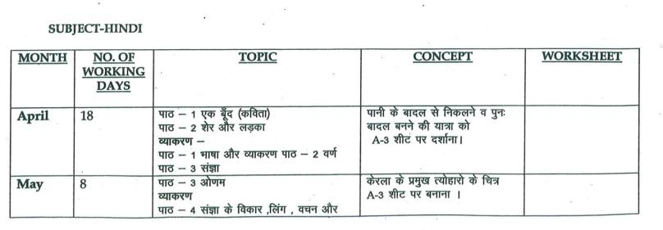
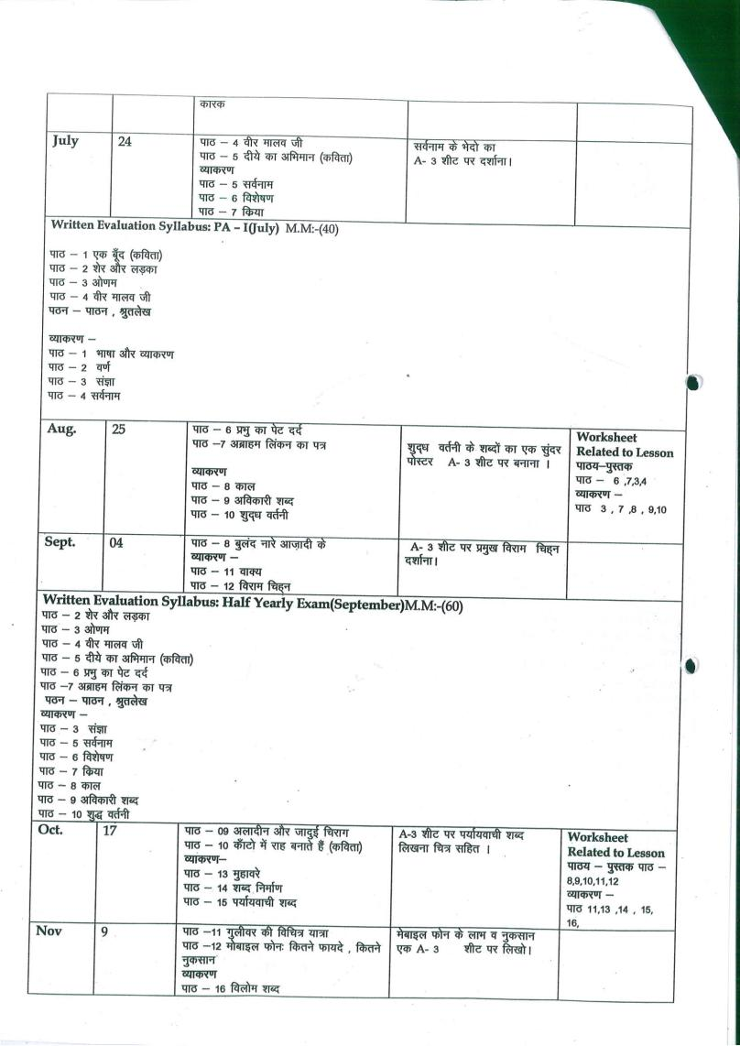
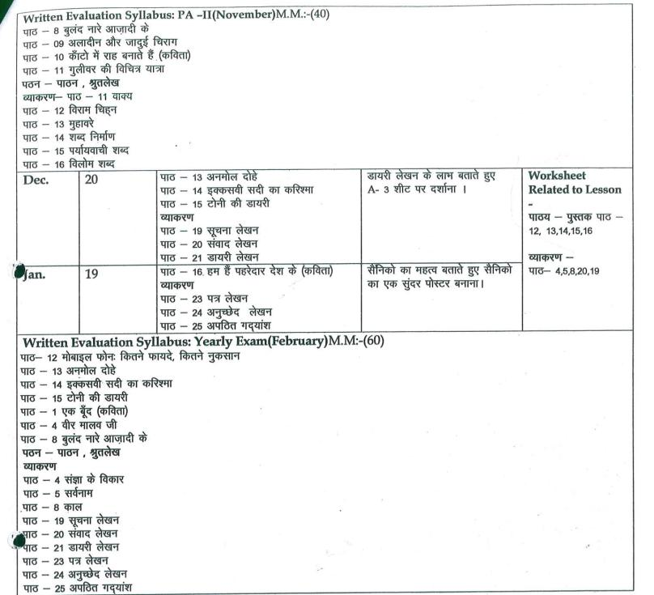
SUBJECT-MATH

MONTH | NO. OF WORKING DAYS | TOPIC | CONCEPT | ACTIVITY | WRORKSHEET
Apr. | 18 | L-3 Large Numbers  L-4 operation on large numbers | Place value & Face value of numbers | 1.Representation of large numbers on abacus using bindis.  2.Adding 9,99,999--- to any no. (shortcut method) | Work sheet of  L-3+ Tables (2 to 10)
May | 8 | L-4 operation on large numbers (Cont.) | Calculation & numeracy skills | L-17 Basic geometrical concept | Work sheet of  L-4
Jul. | 24 | L- 5simplification  L-6 Factors & multiples  L-19 Parallel& perpendicular lines(Activity based) | 1.HCF & LCM  2.Types of lines | 1.To find multiples and factors.  2.Identifying parallel& Perpendicular lines in different polygons. | Recapitulation of PA chapters+ Tables 2 to 15
Written Evaluation Syllabus: PA-I(July) MM(40)
L-3 Large Numbers
L-4 operation on large numbers
L-5 Simplification
L-6 Factors & multiples
L-19 Parallel& perpendicular lines
Aug. | 25 | L-16 Money  L-18 concept of angles  L-20 Triangles  L-7 Fractions | 1.Classification of angles & triangles.  2.Learning about numbers less than whole. | 1.Triangles by paper folding.  2.Making a fraction disc. | Worksheet of  L-18,20,7+ Tables 16 to 18
Sep. | 4 | L-21 circles | Learning about relation between radius and diameter, circumference of a circle | Finding the circumference of circle using a compass ,thread and a ruler. | Recapitulation of Half yearly chapters + Tables 2 to 18
Written Evaluation Syllabus: Half yearly Exam(September) MM(60)
L-4 operation on large numbers
L-5 Simplification
L-7 Fractions
L-16 Money
L-18 concept of angles
L-19 Parallel& perpendicular lines
L-20 Triangles
L-21 circles
Oct. | 17 | L-8 Addition & subtraction of fractions  L-9 Multiplication & division of fractions  L-25 Pictograph | - Operation on fractions  - Learning about data handling | Collect data of the favorite chocolate of students of class 5 and prepare a pictograph. | Worksheet of fractions + Tables 18 to 20
Nov. | 9 | L-10 Decimals  L-13 Average | Place value chart of decimals | Bill making activity using the four operations on decimals. | Recapitulation of PA chapters
Written Evaluation Syllabus: PA-II(November) MM(40)
L-8 Addition & subtraction of fractions
L-9 Multiplication & division of fractions
L-10 Decimals
L-13 Average
L-25 Pictograph
Dec. | 20 | L-12 Measurement  L-14 Percentage  L-15 Time | * Conversion of units of measurement  * Learning about 12-hr & 24-hr clock. | To find out weight of family members and do the conversions. | Worksheet of L-12,15
Jan. | 19 | L-22 Perimeter  L-23 Area  L-24 Volume | Perimeter, area and volume of figures. | Using OHP sheets and marker pens prepare a cuboid and calculate its area and volume. | Recapitulation of yearly chapters+ Tables 2 to 20
Written Evaluation Syllabus: Final Exam(February)MM(60)
L-10 Decimals
L-12 Measurement
L-13 Average
L-14 Percentage
L-15 Time
L-22 Perimeter
L-23 Area
L-24 Volume

SUBJECT-SCIENCE
MONTH | NO OF WORKING DAYS | TOPIC | CONCEPT | ACTIVITY | WOKSHEET
April | 18 | L-1 , Growing Plants  L-6, Animals-Habitat and Adaptation  L-3,Safety and First Aid | 1. Showing activity on seed germination in the class.  2. To enable the students to write their own answers with the help of creative writing.  1. Showing pictures of different types of habitats.  1. Showing first aid box and demonstrating different safety measures for fractures, burns, nose bleed and sprains in the class.. | 1. Collect different types of seeds and paste them on A4 sheet and find out if these have any special features e.g spines or hair etc.  1. Make 5 flash cards of five animals living in different habitats.  1.Find out important helpline numbers of some places e.g fire station, police station, nearest hospital and write on A4 sheet. Put it up in your room. | Worksheet based on L-1and 6
May | 8 | L-2, Food and Health | 1. Showing flash cards of sources of different nutrients and balanced diet. | 1 .Collect any four wrappers of food items and paste them in the chart and write their nutritional information as well. | Worksheet  based on L-2 and 3
July | 24 | L-7, Skeletal System and Nervous System  L-4,Solids,Liquids and Gases | 1. Visiting the lab to show skeletal system.  2. Showing the model of an eye and ear.  3. Activity on reflex action.  1. Showing experiments on evaporation, condensation, miscible and immiscible liquid. | Draw, colour and label structure of an eye on A4 sheet.  1.Collect pictures of things in different states of matter and arrange them in the columns of solids, liquids and gases. | Recapitulation worksheet for PA-1
Written Evaluation Syllabus: PA –I(July) MM(40)
L-1 , Growing Plants
L-2, Food and Health
L-3,Safety and First Aid
L-6, Animals-Habitat and Adaptation
L-7, Skeletal System and Nervous System(only define and book exercise)
Aug. | 25 | L-5, Rocks and Minerals  L-8, Measurement | 1. Showing pictures of different types of rocks.  1. Showing different things used to measure length, mass and capacity | 1. Collect and paste the pictures of famous monuments of India and find out the stones they are built of. e.gQutabMinar, TajMahal etc.  1.Collect the pictures of different measuring devices and paste them on A-4 sheet. | Recapitulation worksheet for Half Yearly Exam
Sep. | 4 | Revision for Half Yearly Exams |  |  | .
Written Evaluation Syllabus: Half Yearly Exam(September) MM(60)
L-1 , Growing Plants
L-2, Food and Health
L-3,Safety and First Aid
L-4,Solids,Liquids and Gases
L-5, Rocks and Minerals
L-6, Animals-Habitat and Adaptation
L-7, Skeletal System and Nervous System
L-8, Measurement
Oct. | 17 | L-9, Force and Energy  L- 10,Air and Water | 1. Experiments to show effects of force and types of force.  1. Activities to show that air has weight and it occupies space.  2. Experiment showing filtration, sedimentation and decantation. | 1. Draw ,Paste& label pictures of six simple machines on A4 sheet.  2.Draw and colour different methods of purification according to your R.No.  R.No-1to9-sedimentation & Decantation  R.No.10 to 19 –Loading  R.No-20 to 29-Boiling  R.No.-29 to 35 -Distillation | Worksheet based on L-9 and 10
Nov. | 9 | L-11, Earth, Sun, and Moon | 1. Showing pictures of internal structure of the earth and phases of the moon.  2. Experiment using ball and torch to show lunar and solar eclipse. | 1.Draw, colour and label pictures of the solar and lunar eclipse according to your R. No on A-4 sheet.  1 to 17 – Solar eclipse  18 to 35 –Lunar eclipse | Recapitulation worksheet for PA-2
Written Evaluation Syllabus: PA II(November) MM(40)
L-4,Solids,Liquids and Gases
L-5, Rocks and Minerals
L-9, Force and Energy
L- 10,Air and Water
L-11, Earth, Sun, and Moon

Dec. | 20 | L-12, Light and Shadows  L-13, Volcanoes, Earth quakes and tidal waves | 1. Showing real things related to different types of materials. e.g transparent ,translucent and opaque.  1. Showing picture of cross section of a volcano. | 1. Make a list of 10 objects that you can see in your classroom. Now identify and write whether these are transparent, opaque and translucent.  2. Find out some safety measures to be followed during earth quakes. Write these on A4 sheet. | Worksheet based on L-12and 13
Jan. | 19 | L-14, Our Environment | 1. Discussion on different types of pollutions. | 1. Draw a poster on any of the four types of pollution that you see around yourself and write a catchy slogan on it.
Feb. | 6 | Revision |  |  | Recapitulation worksheet for final exam.
Written Evaluation Syllabus: Yearly Exam(February) MM(60)
L-1 , Growing Plants
L-8, Measurement
L-9, Force and Energy
L- 10,Air and Water
L-11, Earth, Sun, and Moon
L-12, Light and Shadows
L-13, Volcanoes, Earth quakes and tidal waves
L-14, Our Environment

SUBJECT- SOCIAL STUDIES
MONTH | NO. OF WORKING DAYS |  | TOPIC |  | CONTENT | ACTIVITY |  | WORKSHEET
April | 18 |  | L-1. The Globe and the Map  L-2. Parallels and Meridians |  | L-1 Structure of Earth.  L-2. Showing imaginary lines on the equator. | L-1. Draw symbols and color key used in a map.  L-2. Draw Parallels of latitudes and Meridians of longitudes. |  | Given at the back of the Chapter
May | 8 |  | L-3.Weather and Climate |  | L-3. Showing flash cards of different types of Weather. | L-3,  1. Draw the Heat Zones of the Earth  2. Map- Show the various climatic regions of the world |  | Given at the back of the Chapter
July | 24 |  | L-4.The equatorial region  L-5. Tropical Desert  L-6. The Temperate Grasslands |  | L-4. Discussion on The Democratic Republic of Congo.  L-5. Discussion on hot deserts of the world.  L-6.Understanding the Geography of Prairies. | L-4.  1.National Park work grid for Congo  2. Map of Africa  L- 5.  Map: Mark Hot Deserts of the world.  L-6. Paste the picture of wild animals of prairies  Map: Grasslands of the World |  | Given at the back of the Chapter
Written Evaluation Syllabus: PA-I(July) MM:-40
L-1. The Globe and the Map L-2. Parallels and Meridians
L-3.Weather and Climate L-4.The equatorial region
Aug. |  | 25 | L-7. The land of ice and snow  L-8. Environmental Pollution  L-9. Natural Disasters |  | L-7.Discussion on Greenland, its location, climate, vegetation, culture etc.  L-8. Showing flash cards of different types of Pollution.  L-9. Depiction of different types of Natural Disasters through flash cards. | L-7. Make a Harpoon and Draw a kayak.  L-8.Draw a diagram of 3 R’s  L-9.Draw a seismograph |  | Given at the back of the Chapter
Sept. |  | 4 | Revision |  |  |  |  | Worksheet based on above chapters.
Written Evaluation Syllabus: Half Yearly Exam(September) MM:-60
L-1. The Globe and the Map L-2. Parallels and Meridians L-3.Weather and Climate
L-4.The equatorial region L-5. Tropical Desert L-6. The Temperate Grasslands
L-7. The land of ice and snow L-8. Environmental Pollution L-9. Natural Disasters

Oct. |  | 17 | L-10. The world of growing Knowledge  L-11. Age of Machines  L-12. Living longer and healthier |  | L-10. Showing symbols of ancient times.  L-11. Discussion on D Invention of Steam Engine.  L-12. Live depiction of various Medical Gadgets. | L-10. Write 1-10 in Roman and Braille Script  L-11. Draw a windmill and Solar Cooker  L-12. Draw Clinical Thermometer and Stethoscope |  | Given at the back of the Chapter
Nov. |  | 9 | L-13. Some People never die  L-14. Keep in touch |  | L-13. Discussing the life story of Abraham Lincoln.  L-14. Discussion on Mass Communication. | L-13. Write a paragraph to describe an incident when you told truth and work hard and you were successful.  L-14. Draw one device for personal and mass communication |  | Given at the back of the Chapter
Written Evaluation Syllabus: PA-II(November) MM:- 40
L-10. The world of growing Knowledge L-11. Age of Machines
L-12. Living longer and healthier L-13. Some People never die

Dec. |  | 20 | L-15. Conquering distances  L-16.Struggle towards freedom  L-17. India win Freedom | L-15. Means of transport.  L-16.Understanding the impact of Great Revolt of 1857.  L17. Swadeshi and Boycott Movement, Role of Gandhiji |  |  | L-15. Map Work  L-16. Mark the centers of revolt of 1857  L-17.Collect picture of revolutionaries and make a collage | Given at the back of the Chapter
Jan. |  | 19 | L-18. Birth of UN  L-19. The working of the UN | L-18. World War 1 & 2, UN  L-19. Major Organs, agencies and achievements of UN. |  |  | L-18. Draw the symbol of UN  L-19. Draw the symbols of agencies of UN. | Given at the back of the Chapter
Written Evaluation Syllabus: Yearly Exam (February) MM:-60
L-10. The world of growing Knowledge L-11. Age of Machines
L-12. Living longer and healthier L-13. Some People never die
L-14. Keep in touch L-15. Conquering distances
L-16.Struggle towards freedom L-17. India win Freedom
L-18. Birth of UN L-19. The working of the UN

SUBJECT-COMPUTER
MONTH | NO. OF WORKING DAYS |  | CONTENT |  | ACTIVITY | PRACTICAL | WORKSHEET
April | 18 |  | Ch 1 – The World of Computers |  | Draw the Anatomy of Computer. | Power Point | Ch 1
May | 8 |  | Ch 5 – Planning the Presentation |  | Draw five different types of icons used in Power Point. |  | Ch 5
July | 24 |  | Revision + Ch 2- Understanding the software |  | Draw icons of any three types of Application Software. | MS Power Point | Ch 2
Written Evaluation Syllabus: PA –I(July) MM(20)  Ch-1: The World of Computers  Ch 5 – Planning the Presentation  Practical: MS Power Point |  |  |  |  |  |  |  |  |  |  |  | Ch 4 & 6
Aug. | 25 |  | Ch 2- Understanding the software  Ch 6- More on Power Point 2016 |  | Draw icons of any three types of Application Software. | MS Power Point | Ch 4 & 6
Sep. | 4 |  | Revision
Written Evaluation Syllabus: Half Yearly Exam(September) MM(30)
Ch-1: The World of Computers
Ch 2- Understanding the software
Ch 6- More on Power Point 2016
Practical: MS Power Point
Oct. | 17 |  | Ch 4- More on Ms- Word 2016 | Write 8 different Blocks of Scratch in a Rectangular Box and color the box with the respective color code.  Eg.- Motion-Blue; Looks-Purple. |  | Word &  Scratch | Ch 4
Nov. | 9 |  | Ch 8 – Programming with Scratch |  |  |  | Ch 8
Written Evaluation Syllabus: PA II(November) MM(20)
Ch 4- More on MS- Word 2016
Ch 8 – Programming with Scratch
Practical: MS Word
Dec. | 20 | Ch 9- Event Programming with Scratch  Ch 7- Introduction to MS-Excel 2016 |  | Draw and label MS Excel Window |  | Scratch +  MS Excel | Ch 9 &  Ch 7
Jan. | 19 | Ch 10 –Browsing the Internet |  | Draw four different types of browsers. |  |  | Ch 10
Feb. | 6 | Revision
Written Evaluation Syllabus: Yearly Exam(February)MM:-30
Ch 9- Event Programming with Scratch
Ch 7- Introduction to MS-Excel 2016
Ch 10 –Browsing the Internet
Practical: Scratch

SUBJECT- G.K.

MONTH | NO.OF WORKING DAYS | CONTENT
April | 18 | Page no. 3 to Page no. 11 and Page no. 65
May | 8 | Page no. 12 to Page no.17
July | 24 | Page no. 18 to Page no. 20  Revision
Written Evaluation Syllabus: PA-I(July) M.M.- 20
Page no. 3 to Page no. 17 and Page no. 65
Aug. | 25 | Page no. 21 to Page no.32 ,  Page no. 67 and Page no. 68  Current Affairs
Sept. | 4 | Revision
Written Evaluation Syllabus: Half Yearly Exam(September) M.M.-30
Page no. 18 to Page no. 32
Page no 67 and Page no. 68
Current Affairs

Oct. | 17 | Page no. 33 to Page no. 43, Page no. 69 and  Page no. 70
Nov. | 9 | Page no. 44 and Page no. 45  Revision
Written Evaluation Syllabus: PA-II(November) M.M.-20
Page no. 33 to Page no. 45
Page no. 69 and Page no. 70
Dec. | 20 | Page no. 46 to Page no. 59 and Page no 66
Jan. | 19 | Page no 60 to Page no.64  Page no 71 and Page no. 72  Current Affairs , Revision
Feb. | 6 | Revision
Written Evaluation Syllabus: Yearly Exam(February) M.M.-30
Page no. 46 to Page no 64
Page no. 66, Page no. 71 and 72
Current Affairs

SUBJECT- ART/CRAFT
MONTH | NO. OF WORKING DAYS | PAGES OF ART BOOK | ACTIVITY
April | 18 | 3-4, 19, 20 | Caterpillar – Corrugated sheet 19  Tiger – Grid activity 20
May | 8 | 5,6,30 | African mask – wool pasting 30
July | 24 | 7,8,9,21,22,32,33 | Crane – Lead powder and eraser 21  Swan – sand paper 32
Written Evaluation Syllabus: Half-Yearly Exam(September)
Page no.: 3 to page no. 11
Page no.: 19 to 24
Page no.: 30 to 35
Aug. | 25 | 10,11,23,24,34,35 | Flamingo – Foam pasting 34  Glowing fish – shell pasting and scratching technique 35
Sep. | 4 | Revision
Oct. | 17 | 31,36,12,13,37 | Rangoli making – wood powder 31  Candles – glitter + star pasting 36
Nov. | 9 | 14,15,25,26,38,39 | Texture art 26  Pen stand – clay molding 39
Dec. | 20 | 16,17,27,28,40 | Rooster – paper folding
Jan. | 19 | 18, 29
Feb. | 6 | Revision
Written Evaluation Syllabus: Yearly Exam(February)
Page no. : 12-18, 25, 29, 31
Page no. 36 to Page no. 40

SUBJECT-DANCE
Month | Number of Working Days | Topic
April | 18 | Aerobics and body stretching exercises
May | 8 | Aerobics and body stretching exercises
July | 24 | Free style dancing , Bhangra/Gidda (Independence celebration)
Aug. | 25 | Free style dancing , Bhangra/Gidda (Independence celebration)
Sep. | 4 | Folk dances and basic classical movements(Dussehra&Navratri celebration)
Oct. | 17 | Folk dances and basic classical movements(Dussehra&Navratri celebration)
Nov. | 9 | Salsa dance and western bollywood dance(Christmas celebration)
Dec. | 20 | Salsa dance and western bollywood dance(Christmas celebration)
Jan. | 19 | Patriotic dance , hip-hop style and line dance(Republic day celebration)
Feb. | 6 | Patriotic dance , hip-hop style and line dance(Republic day celebration)
- Presentation of houses activity

